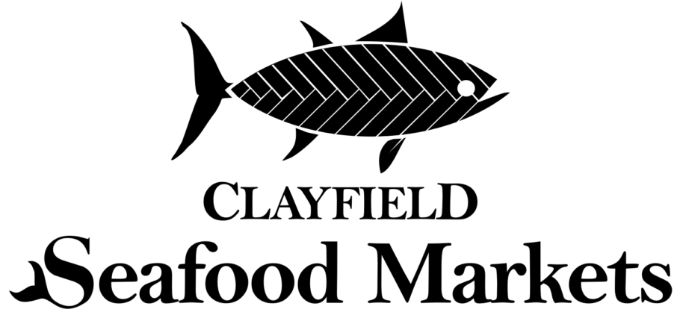
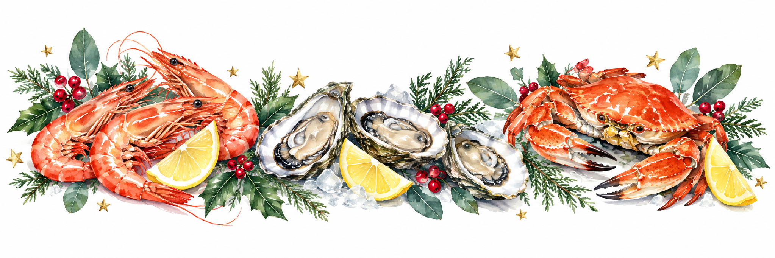
Shop 5/823 Sandgate Road, Clayfield 4011 | 07 3262 6279
christmas@clayfieldseafood.com.au | www.clayfieldseafood.com.au

2026 Christmas seafood pre order form
Name ___________________________________ Contact number _________________________
Email ___________________________________ Pick-up date ____________________________
Product list | Approx. price | Quantity | Total
Cooked Mooloolaba King Prawns Large 10/15 (Shell On)- (QLD) | $64.90 / kg
Mooloolaba Green Prawn Cutlets (Shell Off) 1kg Bags Frozen - (QLD) | $84.90 / kg
Pacific Oysters freshly shucked – South Australia or Tasmania | $29.90 / Dozen
Moreton Bay Large Bug cooked 200gr approx | $19.90 / Each
Fresh Whole fillet Tasmanian Salmon (TAS) Skin On (1.2kg-1.5kg) | $74.90 / Each
Whole Cooked Sandcrab (Shell On) - (QLD) | $14.90 Each
Live Mussels 1kg Bags – South Australia (SA) | $15.90 / kg
Lobster Whole Cooked - Western Australia (WA) | $69.90 / Each
SMALL Prawn & Oyster Pack  1kg Cooked King Prawns, 1 dozen Coffin Bay Oysters with Seafood Sauce, Lime & Chilli Jam Aioli, & Asian Oyster Topper & Fresh lemon | $89.90 / Each
LARGE Prawn & Oyster Pack  3kg Cooked King Prawns, 3 dozen Coffin Bay Oysters with a Trio of our sauces, Oh My Oyster Classic French Mignonette & Fresh lemon | $284.90 / Each
SMALL DELUXE for 2 People  ½ Kg Cooked King Prawns, 1 dozen Coffin Bay Oysters, 1 Large Moreton Bay Bug, 1 Sandcrab with a trio of our sauces & Fresh lemon | $94.90 / Each
DELUXE Christmas Seafood Pack  Fresh Western Australian Lobster, 2kg Cooked King Prawns, 2 dozen Coffin Bay Oysters, 2 Large Moreton Bay Bugs, 2 Cooked Sand Crabs with a Trio of our sauces, Oh My Oyster Classic French Mignonette & Fresh lemon | $329.90 /Each
Special seafood requests  Ask our friendly Senior Staff regarding specialties. | Market price

Seafood total $ __________________

Christmas extras and order details

Homemade sauces
Clayfield Seafood Market Sauces • 200 ml • $6 each
Condiment | Qty | Condiment | Qty | Condiment | Qty
Housemade Tartare Sauce |  | Lime & Chilli Jam Aioli |  | Mango & Basil Mayo
Tangy Seafood Sauce |  | Lemon, Dill & Tarragon Aioli |  | Roasted Garlic Aioli

Oyster toppers
Oyster topper | Price each | Qty
Asian Oyster Topper 60ml | $3.00
Kilpatrick 250ml Topper | $6.00
Wakame with Sesame Dressing 60ml | $3.00
Oh My Oyster Australian Native Vinaigrette 50ml | $11.00
Oh My Oyster Yuzu Sesame Vinaigrette 50ml | $11.00
Oh My Oyster Classic French Mignonette 50ml | $11.00

Condiments total $ __________________

Packaging and totals
Packaging and order summary | Amount
Compulsory packaging fee  Includes reusable cooler bag, packed ice and fresh lemon | $8.00
Optional large polystyrene box — $6 each Quantity ______ | $ __________
Order total | $ __________
Grand total | $ __________

Ordering and collection
For your convenience, our full range of fresh and cooked seafood, along with our regular in-store items, will be available for purchase until 4:00pm on Christmas Eve.
A $50 deposit is required to secure your Christmas pre-order. Payment can be made in store or over the phone. Alternatively, you can place and pay for your order online at www.clayfieldseafood.com.au.
Completed order forms can be emailed to christmas@clayfieldseafood.com.au or returned directly to the store, where one of our senior staff members will be happy to assist you.

Please note that due to high Christmas demand, prices and availability are subject to change. Pre-orders close COB Saturday 19 December. Christmas order collections are available Wednesday 23 December from 8am–8pm and Thursday 24 December from 6am–4pm. We are CLOSED Christmas Day and Boxing Day and will reopen Sunday 27 December from 11am. A $50 deposit is required when placing your order, with the remaining balance payable on collection.

By signing below, you confirm that you have read and understood the disclaimer at the bottom of each page.
Customer signature _________________________________________________________
Date ordered _____________________ Order taken by __________________________

Wishing you a delicious Christmas!

